**Non-Linear Programming.**   
  
Amazon must determine how many business analytics positions should open within the next two years. If Amazon opens x1 positions in 1 year, the company would make a profit of 80,000 - x1 dollars. If Amazon open x2 positions in 2 years, the company would make 85,000 - x2 dollars.

The cost of providing x1 jobs during year 1 would be $2{000x}_{1}^{2}$ dollars, and the cost of providing x2 jobs during year 2 would be $3{000x}_{2}^{2}$ dollars. A total of 200 business analytics positions are available and Amazon can spend at 250,000 dollars on providing these jobs.

Determine how Amazon can maximize its profit by providing jobs for the next two years.

**Discussion.**This is an example of a non-linear programming model to maximize profit. The model is non-linear because the objective function is an algebraic equation of degree greater than 1, making the boundary of the feasible region non-linear. The rest of the mathematical model remains similar to that of a linear model. The constraints ensure that the decision variable (No. of jobs provided) is an integer and does not exceed the maximum number of positions that can be exceeded over the 2 years. In order to maximize the objective, we must try to provide as many business analytics jobs as we can subject to the constraint B that the cost price does not exceed the budget available. The decision is how many job opportunities need to be provided by Amazon for over 2 years.

**Model.**

Parameters:

80,000 - $x_{1}$: Unit profit for providing $x_{1}$ jobs in year 1

85,000 - $x_{2}$: Unit profit for providing $x_{2}$ jobs in year 2

$2{000x}_{1}^{2}:$ Cost of providing $x_{1}$ jobs during year 1

$3000x_{2}^{2}:$ Cost of providing ${ x}_{2}$ jobs during year 2

M: Maximum number of business analytics positions available, M = 20,000

B : Available budget for providing the jobs ($250,000)

Decisions:

${{ x}_{i} }_{ }$: *Number of jobs to be provided in year $i$, where $i$ $∈\{1,2\}$*

Objective: *Maximize profit*

$max$ [ (80,000 - $x_{1}$) $x_{1}$* + (85,000 - $x_{2})*$ $x_{2}- 2000x_{1}^{2}-$ $3000x_{2}^{2 }]$

Constraints:

$\sum_{i}{}{ x}_{i}≤M$ (3) Maximum number of positions available

$2{000x}_{1}^{2}+$ $3000x_{2}^{2}≤B (4)$ Budget available

**Optimal Solution.** The following is the solution obtained from Excel Solver.

A maximum profit of **$3493369.27** be attained by Amazon by providing business analytics jobs over the 2 years as shown below..

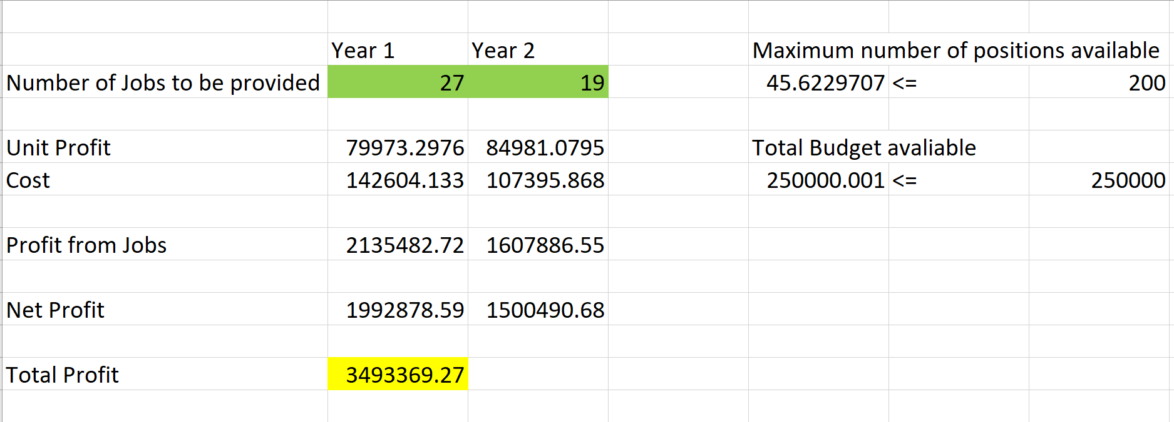

[Scaling -

1. Scaled the cost of providing jobs and the profit by 1000
2. Scaled the number of open positions from x1 million to x1
3. Scaled total number of open positions to 200
4. Scaled Amazon’s budget to 250,000]